

Recipe Management Ontology

Student: Qëndresa Hajdari Prof: Ermira Daka

Prishtine, January 2025

Table of content

Introduction 3

Problem Definition 3

Ontology Design 4

Ontology Specification 6

Ontology Development 7

SPARQL Query Examples 8

Data Integration 9

Application Development 10

Validation and Consistency Check 11

Tools and Technologies 11

Conclusion 11

# Introduction

Recipe Management Ontology is designed to manage information related to cooking recipes, ingredients and kitchen categories. The ontology facilitates the organization, search and sharing of structured knowledge about cooking recipes and their ingredients.

The purpose of the ontology is:

* To support use cases such as recipe discovery,
* Filter recipes according to different preferences.

The ontology includes:

* Classes
* Object Properties and Data Properties
* Relationships between concepts and taxonomic hierarchy

# Problem Definition

In the modern world, managing recipes and their ingredients is a challenge for many people, especially those who want to cook healthy and personalized meals. The lack of an organized system to manage this information leads to:

* Difficulty in finding recipes based on available ingredients.
* Lack of a clear structure for categorizing recipes by cuisine, food category, or dietary preferences.
* Waste of time searching for suitable recipes.

Ontology Design

In the domain analysis phase, the main concepts and the relationships between them were identified. The ontology is designed to meet the needs of managing recipes and their ingredients. In this project are identified:

* **Key Concepts**
  + Some of the main concepts are Recipes that represent the art of cooking, Ingredients – that represent the components needed for a recipe, Category – that represent food classifications, Cuisine – that represent a culinary culture, as well as others.

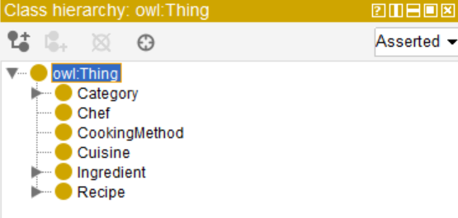

* **Relationships**
  + Here we have the links where the recipes have ingredients, then the recipes belong to a category, or are even linked to specific cuisines. For example, Recipes have ingredients (hasIngredients), recipes belong to a category (belongsToCategory), etc.

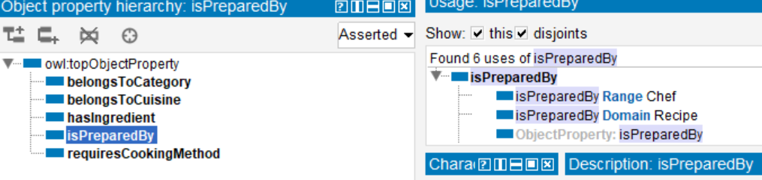

* **Hierarchies and Taxonomies**
  + In Hierarchies and Taxonomies - for example, we have in Category subclasses DietaryCategory and MealCategory, in Ingredients we have subclasses Proteins and Vegetables, and for Recipe we have subclasses AppetizerRecipe, DessertRecipe, DrinkRecipe and MainCourseRecipe.

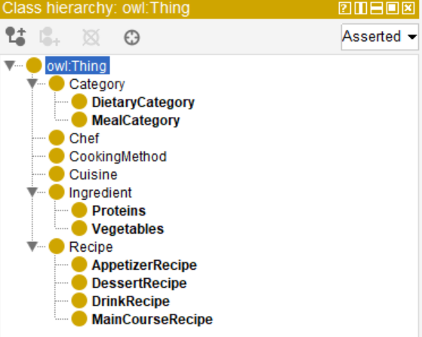

Also, below is a graph of structure of ontology:

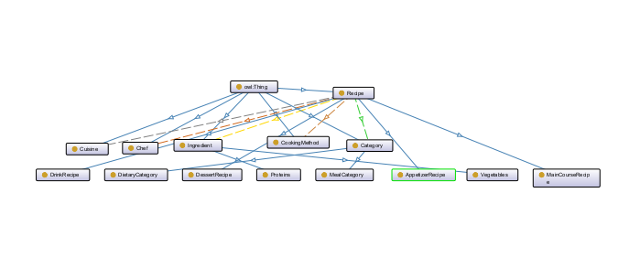

## Ontology Specification

The Recipe Management Ontology is designed to answer several questions:

* What are the ingredients of a specific recipe?
* Which categories does a prescription belong to?
* Which cuisine does a recipe belong to?

While solving these problems:

* Facilitates searching for recipes
* Organizes recipes by categories and cuisines
* Different preferences for cuisines, diets, etc.

**The main elements of Ontology**

The classes and subclasses included in this ontology are:

* Category
  + DietaryCategory
  + MealCategory
* Chef
* CookingMethod
* Cuisine
* Ingredient
  + Proteins
  + Vegetables
* Recipe
  + AppetizerRecipe
  + DessertRecipe
  + DrinkRecipe
  + MainCourseRecipe

In object properties are included:

* hasIngredient, - Lidh recetat me përbërësit
* belongsToCategory – Lidh recetat me kategori të ushqimeve
* belongsToCuisine – Tregon kulturës e një recete prej nga vjen
* requiresCookingMethod – Tregon metodat e gatimit
* isPreparedBy – Lidh recetat me kuzhinierët

In data properties are included:

* creationDate, (dateTime)
* hasDescription (string)
* hasName (string)
* servingSize (integer)
* hasCalories (integer)
* cookingTime (integer)
* preparationTime (integer)

## Ontology Development

The Ontology for Recipe Management was developed using the **Protégé** tool and exported in OWL format. The development process of this ontology contains:

* Creation of 14 main classes and subclasses
* Definition of 5 Object Properties
* Definition of 7 Data Properties
* Adding some instances/individuals such as "SpaghettiTomatoSauce", "Tomato", etc.

An example of the use of ontology can be: The recipe "SpaghettiTomatoSauce" has ingredients "Tomato", "OliveOil" and belongs to Italian cuisine.

## SPARQL Query Examples

PREFIX : <http://example.org/ontology#>

PREFIX rdf: <http://www.w3.org/1999/02/22-rdf-syntax-ns#>

SELECT ?recipe

WHERE {

?recipe rdf:type :Recipe ;

:belongsToCuisine :Mediterranean .

}

PREFIX : <http://example.org/ontology#>

PREFIX rdfs: <http://www.w3.org/2000/01/rdf-schema#>

PREFIX rdf: <http://www.w3.org/1999/02/22-rdf-syntax-ns#>

SELECT ?recipe ?recipeName WHERE {

?recipe rdf:type :Recipe .

?recipe :hasIngredient ?ingredient .

?ingredient rdfs:label ?hasIngredient .

FILTER (regex(?hasIngredient, "${ingredient}", "i"))

?recipe rdfs:label ?recipeName .

}

PREFIX : <http://example.org/ontology#>

PREFIX rdf: <http://www.w3.org/1999/02/22-rdf-syntax-ns#>

PREFIX rdfs: <http://www.w3.org/2000/01/rdf-schema#>

SELECT ?chefName WHERE {

:BeefStew :isPreparedBy ?chef .

?chef rdfs:label ?chefName .

}

# Data Integration

One of the main challenges in data integration is ensuring its quality. In this project, data was obtained from various sources and integrated into the ontology. To ensure that the data was accurate and aligned with the ontology, several steps were taken:

* Data Verification - Data is verified to ensure that it is complete and accurate. For example, recipes must have all their ingredients and be associated with the correct categories and cuisines.
* Ontology Alignment - Data is aligned with the ontology structure. For example, each recipe must have its relationships with ingredients, categories, and cuisines defined.
* Consistency Validation - Using the HermiT Reasoner tool to check that the ontology and data are consistent and without any error.

While the challenge has been the lack of data because some recipes may lack important information, such as ingredients or cooking time.

# Application Development

This application or this project includes the development of a web application, this is an integrated ontology created in Protégé, which is designed to manage and search for recipes according to their ingredients. The application uses semantic web technologies, including SPARQL queries, which pulls data from the ontology, and provides users with advanced search capabilities.

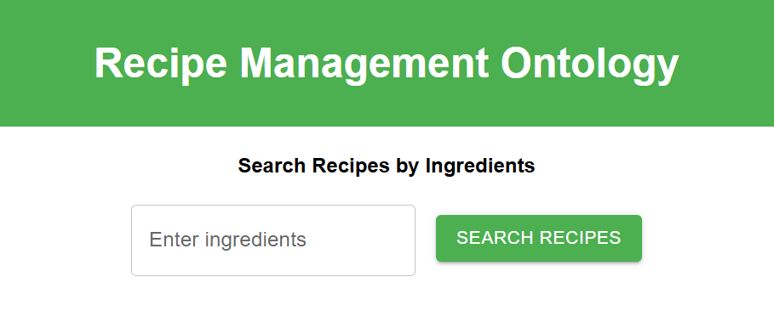

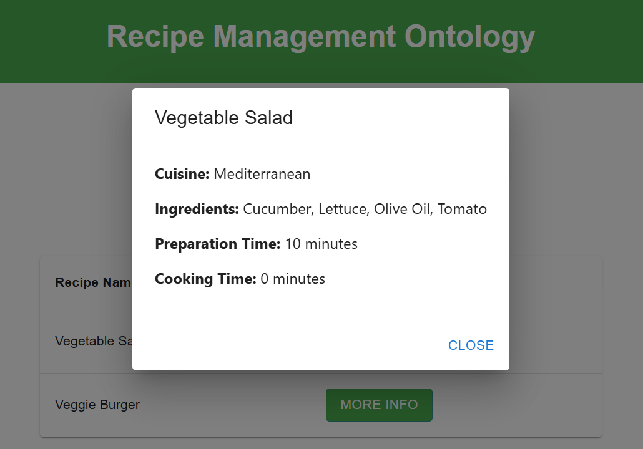

# Validation and Consistency Check

For validation was used HermiT Reasoner tool. According to this control, no inconsistencies were identified and all classes, properties and instances were verified as functional.

# Tools and Technologies

* Ontology Development: Ontology is designed using Protégé with OWL2 format. For validation was used HermiT Reasoner tool.
* Semantic Querying: SPARQL, TriplyDB
* Web Development:
  + Frontend Development
    - Framework: ReactJS
    - Libraries: Material-UI
    - Axios for HTTP request to communicate with SPARQL endpoint
* Backend Development
  + - SPARQL endpoint

# Conclusion

This web application demonstrates effective integration of ontology-based knowledge systems with practical applications. By using semantic search and user-friendly interface, makes it an attractive platform for recipes.